Epiphany Sunday January 4, 2026
Prairieland Parish
As we unite in worship today, we extend a warm welcome to each one present. May we together experience the presence of God
+++++++++++++++++++++++++++++++++++++++++++++++++.
We Gather to Prepare Our Hearts to Meet Our Lord

Epiphany Service of Lessons and Carols

Prelude. - Welcome. - Announcements

Opening
The people who walked in darkness have seen a great light. The light shines in the darkness, and the darkness has not overcome it. Those who dwell in the land of deep darkness, on them has the light shined. We have beheld Christ’s glory, glory as of the only Son of the Father. For to us a child is born, to us a Son is given. In him was life, and the life was the light of all people.

Opening Prayer:
Everlasting God, the radiance of faithful souls, who brought the nations to your light and kings to the brightness of your rising: Fill the world with your glory, and show yourself to all the nations; through him who is the true light and the bright morning star, Jesus Christ your Son, our Lord, who lives and reigns with you and the Holy Spirit, one God, now and forever. Amen.

Hymn 220 “Angels from the Realms of Glory” (All Rise)

First Lesson: Isaiah 60:1–6 (NRSV)
Response:
Hymn 399 “Take My Life, and Let It Be” (remain seated)

Second Lesson: Ephesians 3:1–12 (NRSV)
Response:
Hymn #347 “Spirit Song” (remain seated)

Third Lesson: Matthew 2:1–12 (NRSV)
Response:
Hymn 254 “We Three Kings of Orient Are” (All Rise)
Fourth Lesson: John 1:1–14 (NRSV)
Response:
Hymn 261 “Lord of the Dance”. (All Rise)

Fifth Lesson: Matthew 5:14–16 (NRSV)
Hymn 541 “See How Great a Flame Aspires” (Remain Seated)

Service of Word and Table III
(UMH #15)
BREAKING AND SHARING
Prayer of Thanksgiving

Offertory/Doxology/Prayer
God of Light. We take these gifts and present them with love. We rejoice in our ability to share, but long to do more. Help us to be like the magi and carefully plan the gifts we bring you. May we not be satisfied with what is enough, but instead be inspired to do more. May these gifts be used so others may know the hope that is found in you. In His name, we pray. Amen.

Joys/Concerns

Litany for Epiphany
All the ends of the earth have seen the salvation of our God. Alleluia!
Shout to the Lord, all the earth. Alleluia!
With joy let us pray to our Savior, the Son of God who became one of us, saying:
The grace of God be with us all.
O Christ, let your gospel shine in every place where the Word of life is not yet received. Draw the whole creation to yourself that your salvation may be known through all the earth.
The grace of God be with us all.
O Christ, Savior and Lord, extend your church to every place. Make it a place of welcome for people of every race and tongue.
The grace of God be with us all.
O Christ, Ruler of rulers, direct the work and thoughts of the leaders of nations that they may seek justice, and further peace and freedom for all.
The grace of God be with us all.
O Christ, Master of all, support of the weak and comfort of the afflicted,
strengthen the tempted and raise the fallen. Watch over the lonely and those in danger. Give hope to the despairing and sustain the faith of the persecuted.
The grace of God be with us all.

Lord’s Prayer

Departing UMH Hymn 666 “Shalom to You” (All Rise)

Charge and Benediction

Postlude

++++++++++++++++++++++++++++++++++++++++++++++++++++++++++++++
Our Worship has ended - - Now our Service begins”
+++++++++++++++++++++++++++++++++++++++++++++++++++++++++
Prairieland Parish Announcements

Thursday January 15th - 12 O’clock – Noon
Brownsdale UMC will be hosting their Community Noon Lunch.
+++++++++++++++++++++++++++++++++++++++++++++++++++++++++
Confirmation Classes will be scheduled for Weds, January 14th & 28th @ 6:30pm

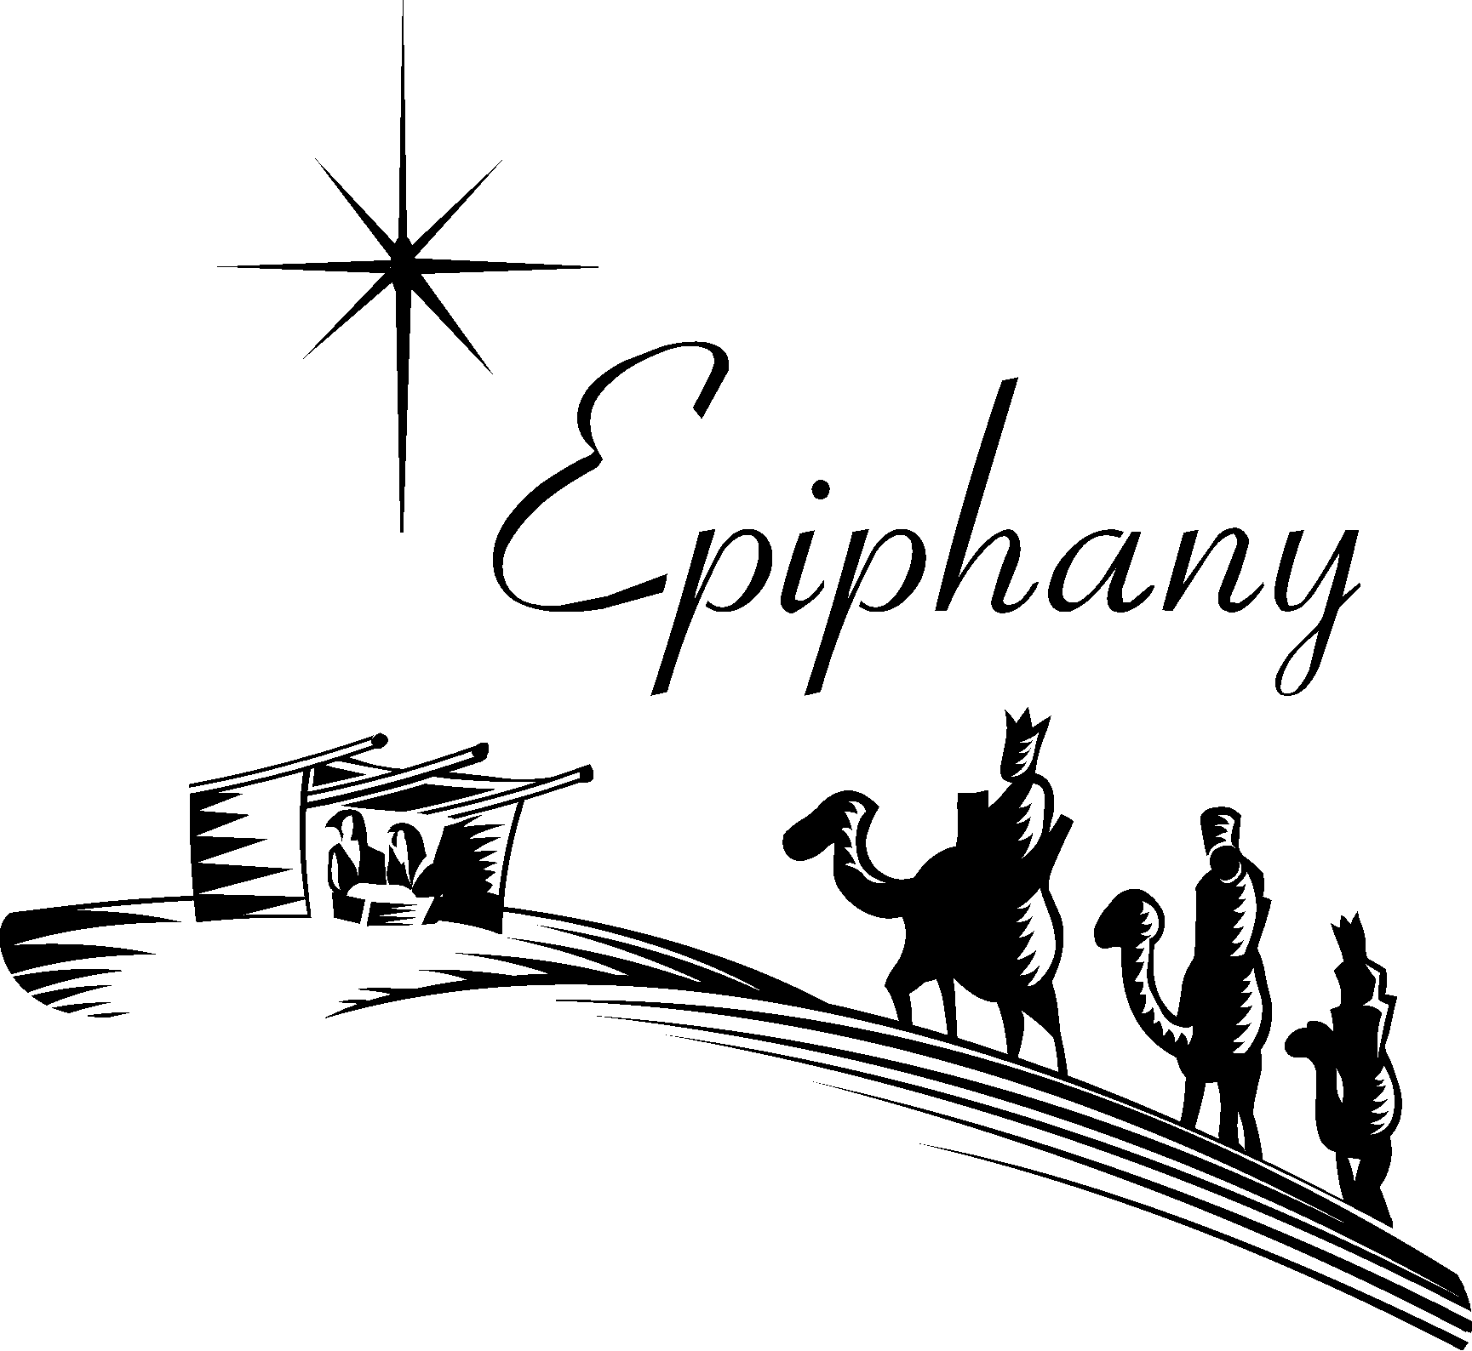
January 4, 2026
Happy New Year!

